Subject: Programming with Java
ASSIGNMENT No: 10
Title
Write a Java program to demonstrate the use of abstract classes and abstract methods.

Problem Statement
Write a Java program to demonstrate the use of abstract classes and abstract methods.

Learning Objectives
- To understand the concept of abstraction in Java.
- To implement abstract classes and abstract methods.
- To learn how subclasses provide implementations for abstract methods.
- To improve code flexibility, reusability, and maintainability using abstraction.

Theory
An abstract class in Java is a class that cannot be instantiated directly. It is declared using the abstract keyword and can contain both abstract methods (without implementation) and concrete methods (with implementation). An abstract method is a method declared without a body and must be implemented by all subclasses that inherit the abstract class. Abstraction hides implementation details while exposing only the essential features of an object, making programs more secure, modular, and easier to maintain.

Outcome
- Understood the concept of abstraction in Java.
- Learned how to create abstract classes and abstract methods.
- Implemented abstraction using real-world examples.
- Improved understanding of object-oriented programming concepts.

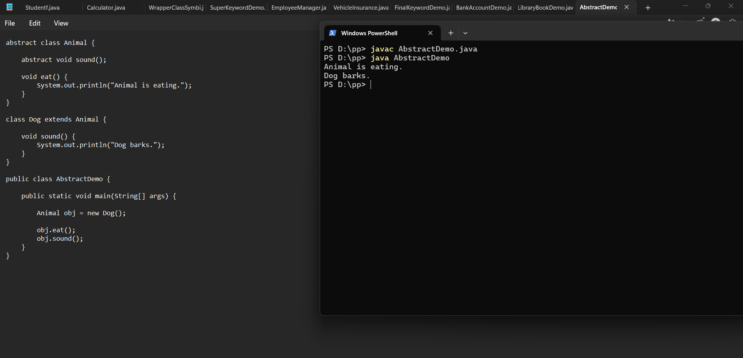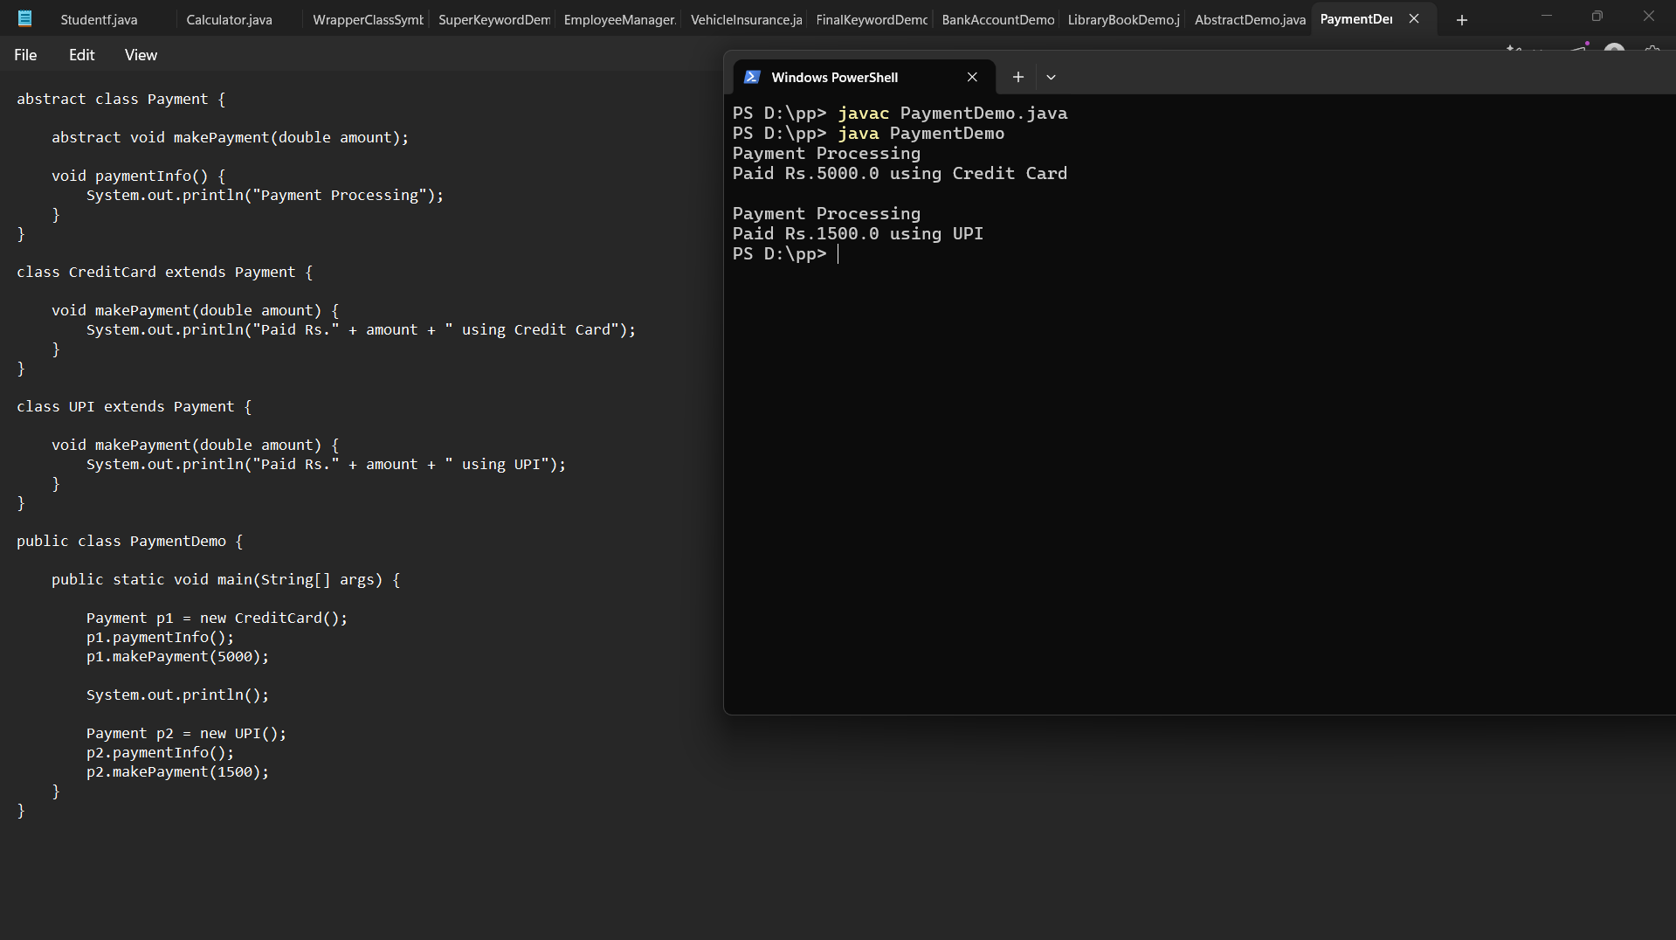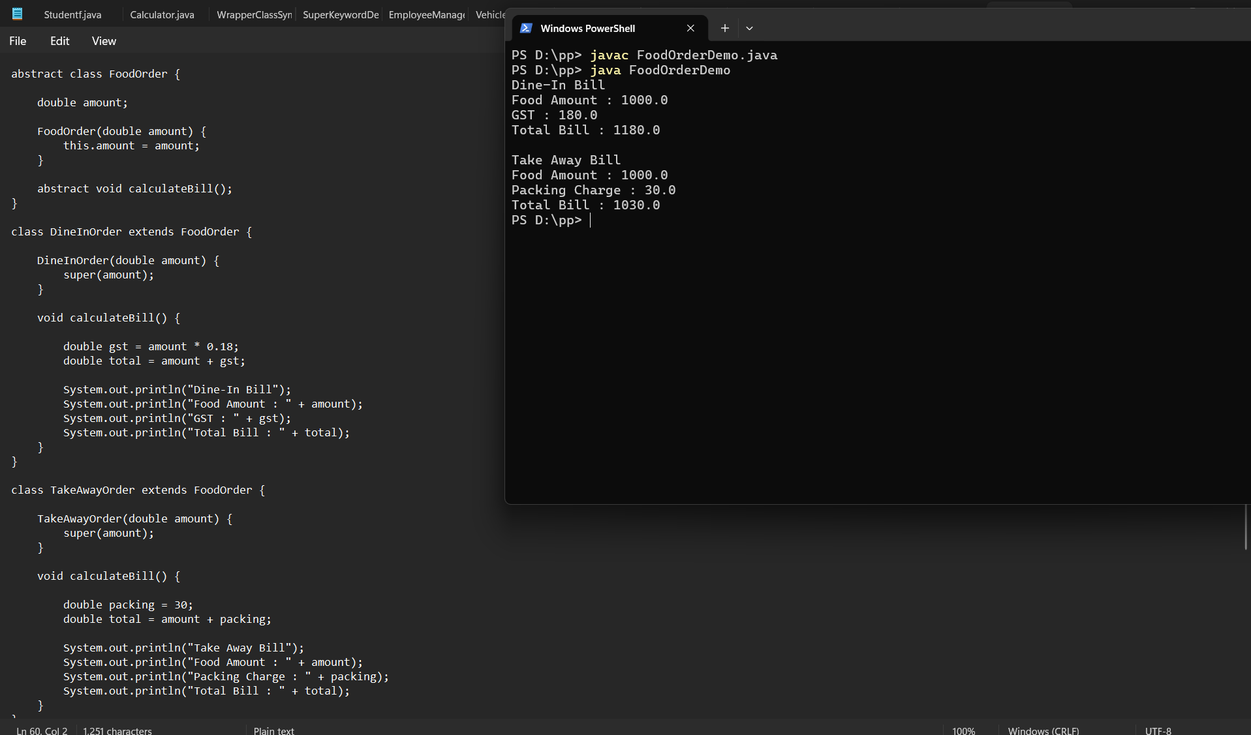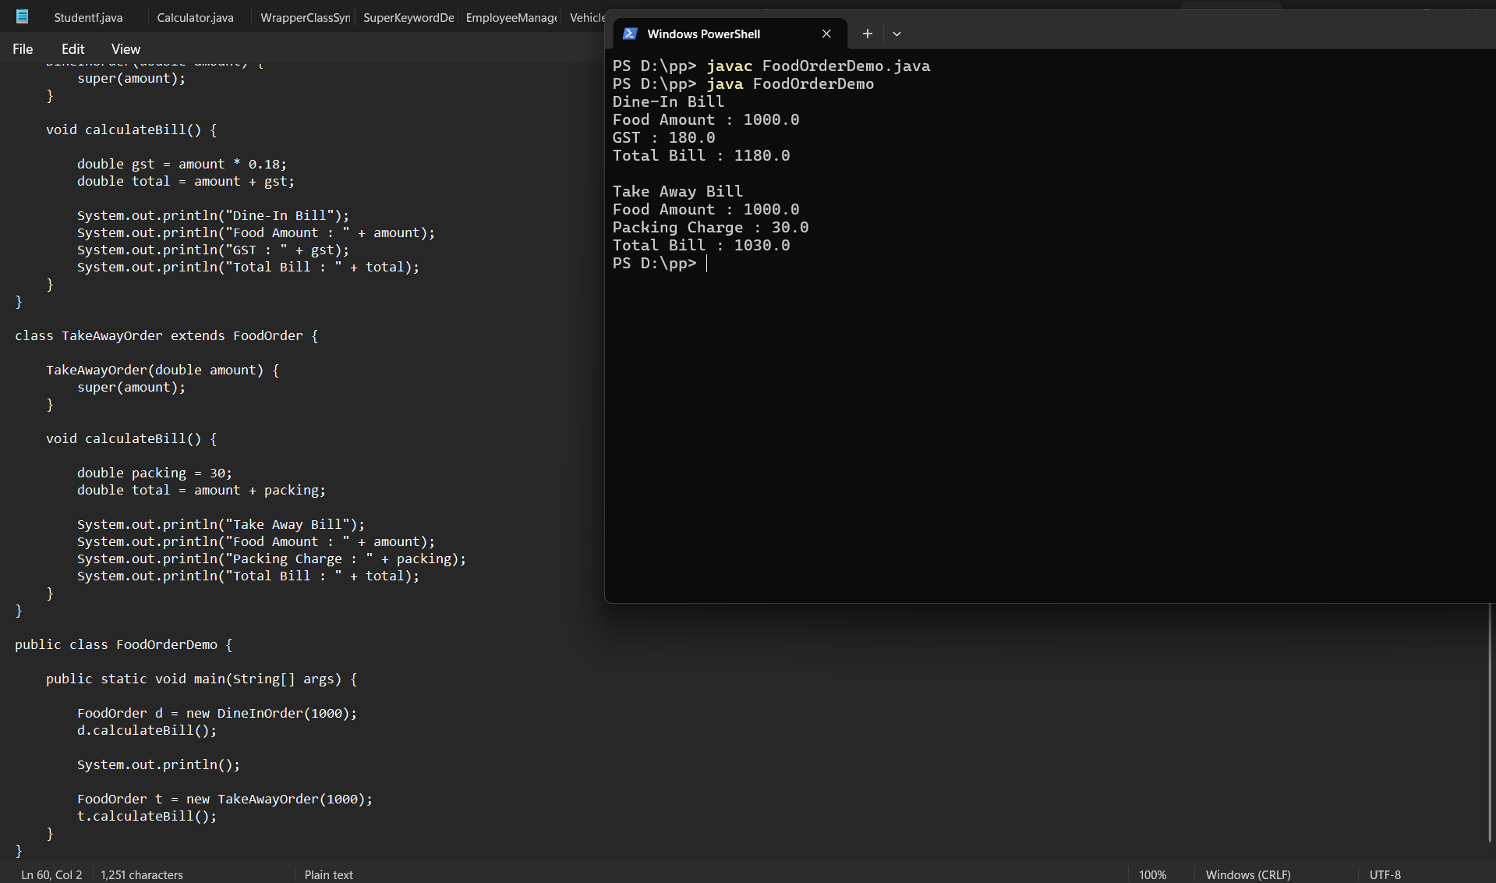

Conclusion
This assignment demonstrated the implementation of abstraction using abstract classes and abstract methods in Java. It showed how abstract classes provide a common structure while allowing subclasses to define their own implementations. Abstraction improves code reusability, flexibility, and maintainability by hiding implementation details and exposing only the required functionality.

